Static Method

1.Write a program to set your name and age by a static method.

class StaticAgeName

{

public static void setage(int a)

{

System.out.println("Age : " +a);

}

public static void setname(String s)

{

System.out.println("Name : " +s);

}

public static void main(String[] args)

{

StaticAgeName.setage(25);

StaticAgeName.setname("Treasa");

}

}

Output :

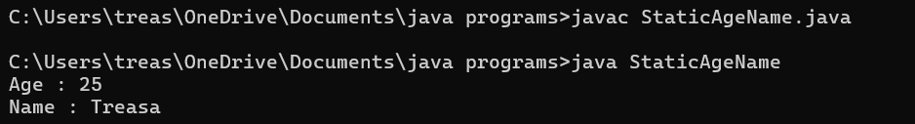

2.Program to find factorial of a number.

Program :

class StaticFactorial

{

public static int fact(int a)

{

int factorial =1;

for(int i=1;i<=a;i++)

{

factorial = factorial \* i;

}

return factorial;

}

public static void main (String args[])

{

int a= 5;

int value = StaticFactorial.fact(a);

System.out.println("Factorial of " + a+ " is " +value);

}

}

Output :

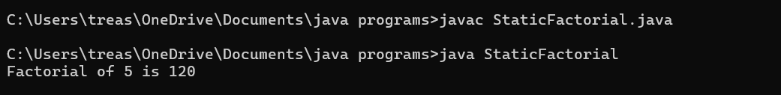

3.Write a program to check whether the given number is palindrome or not.

Method 1 -to find reverse(pass number in argument)

Method 2 – to check palindrome/not

Program :

class StaticPalindrome

{

public static int reverse(int num)

{

int rev = 0;

while(num > 0)

{

int digit =num %10;

rev =rev \*10+ digit;

num=num/10;

}

return rev;

}

public static void palindrome(int n , int val)

{

if(n == val)

{

System.out.println("Number is palindrome");

}

else

{

System.out.println("Number is not palindrome");

}

}

public static void main(String[] args)

{

int val = StaticPalindrome.reverse(123);

System.out.println("Reverse of the number :" +val);

StaticPalindrome.palindrome(123,val);

}

}

Output:

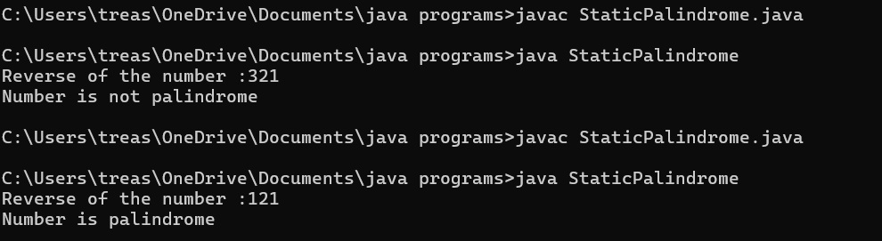

4.Write a program to check whether the candidate is eligible for voting(Use static method and Boolean return type).

Program :

class StaticVote

{

public static boolean vote(int age)

{

if(age>=18)

{

return true;

}

else

{

return false;

}

}

public static void main(String[] args)

{

int age = 20;

Boolean b = StaticVote.vote(age);

System.out.println("Age is " + age);

if(b==true)

{

System.out.println("Eligible for vote");

}

else

{

System.out.println("Not eligible for vote");

}

}

}

Output :

